Write an SQL query to fetch “FIRST_NAME” from Worker table using the alias name as WORKER_NAME>.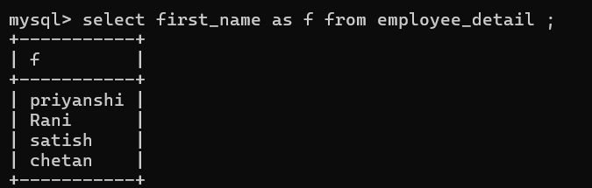

Write an SQL query to fetch “FIRST_NAME” from Worker table in upper case.

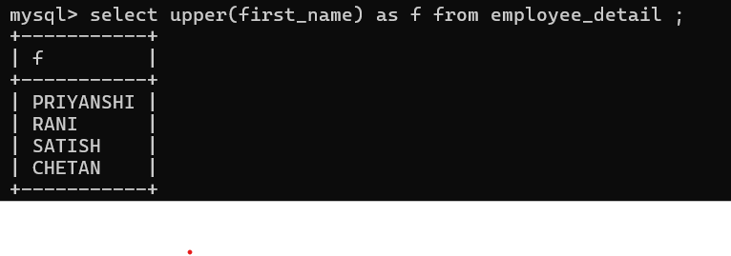Write an SQL query to fetch unique values of DEPARTMENT from Worker table. 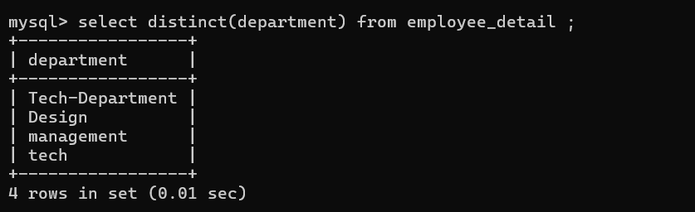

Write an SQL query to print the first three characters of FIRST_NAME from Worker table.

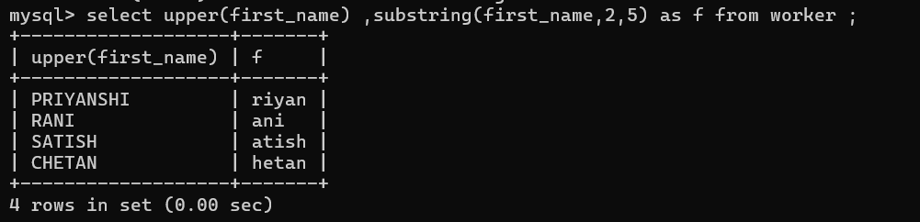Write an SQL query to find the position of the alphabet (‘b’) in the first name column ‘Amitabh’

from Worker table.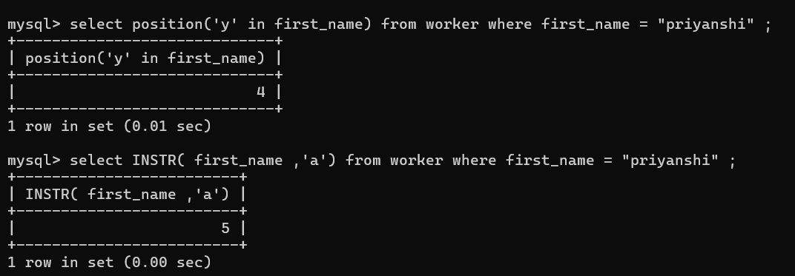Write an SQL query to print the FIRST_NAME from Worker table after removing white spaces from the right side.

Write an SQL query to print the DEPARTMENT from Worker table after removing white spaces from the left side.

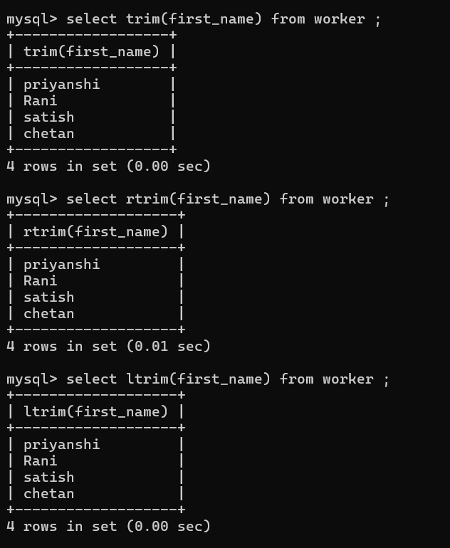

Write an SQL query that fetches the unique values of DEPARTMENT from Worker table and prints its length.

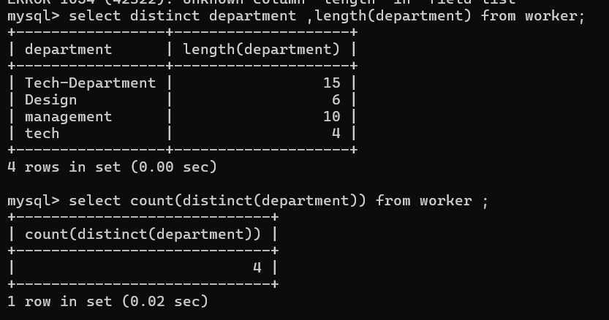Write an SQL query to print the FIRST_NAME from Worker table after replacing ‘a’ with ‘A’. 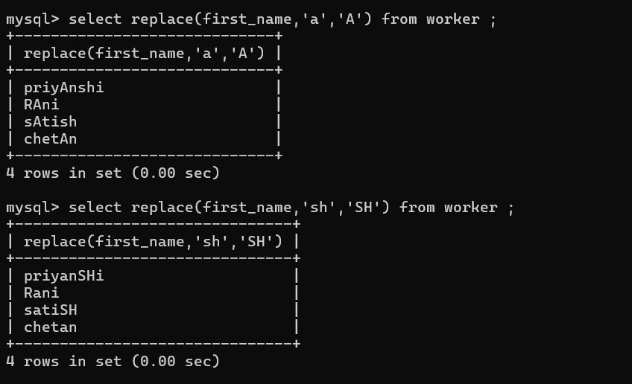

Write an SQL query to print the FIRST_NAME and LAST_NAME from Worker table into a single column COMPLETE_NAME. A space char should separate them.

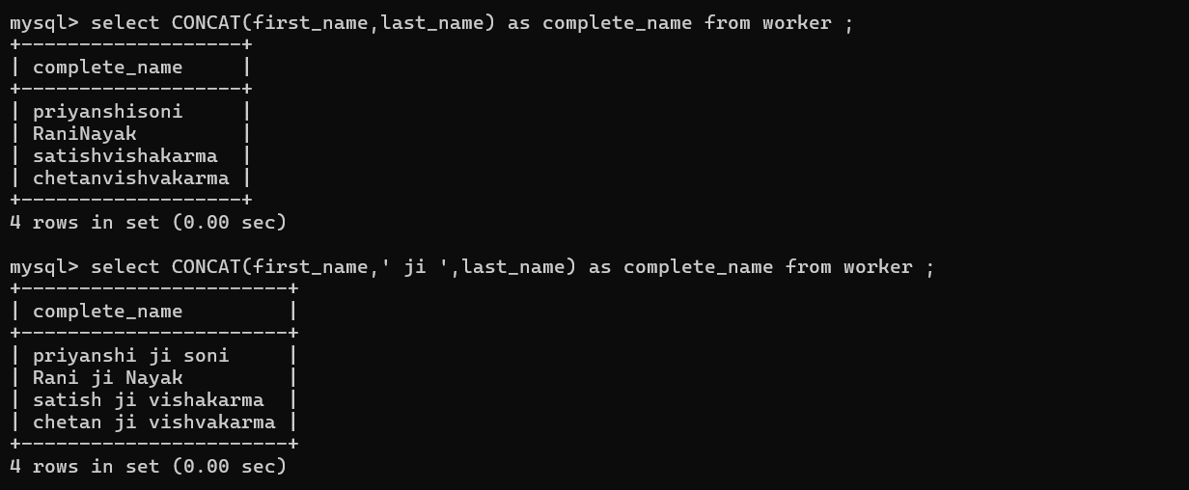

Write an SQL query to print all Worker details from the Worker table order by FIRST_NAME Ascending.

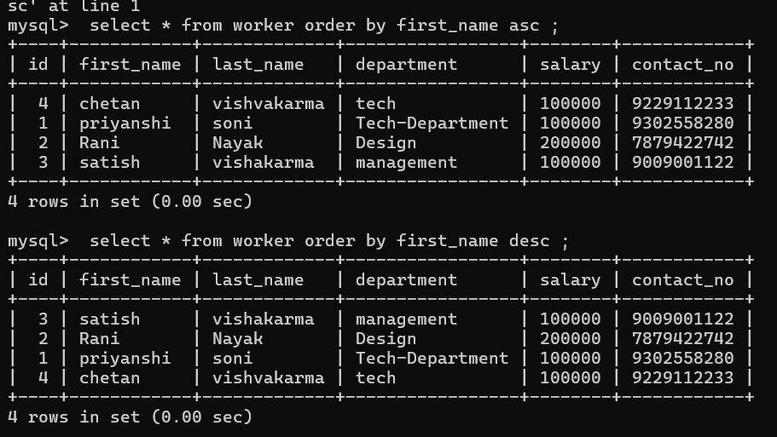

Write an SQL query to print all Worker details from the Worker table order by FIRST_NAME Ascending and DEPARTMENT Descending.

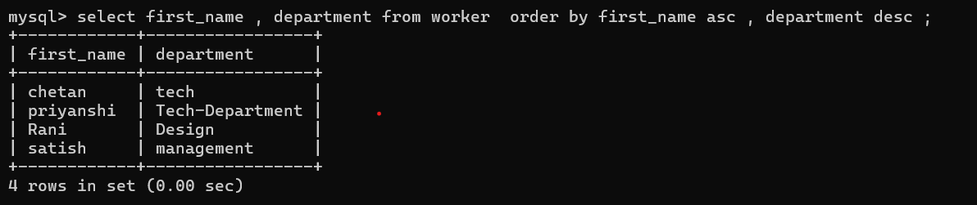Write an SQL query to print details for Workers with the first name as “Vipul” and “Satish” from Worker table.

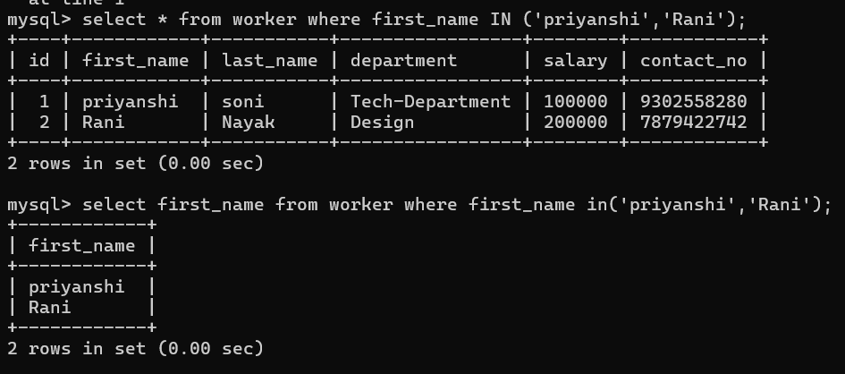

Write an SQL query to print details of workers excluding first names, “Vipul” and “Satish” from Worker table.

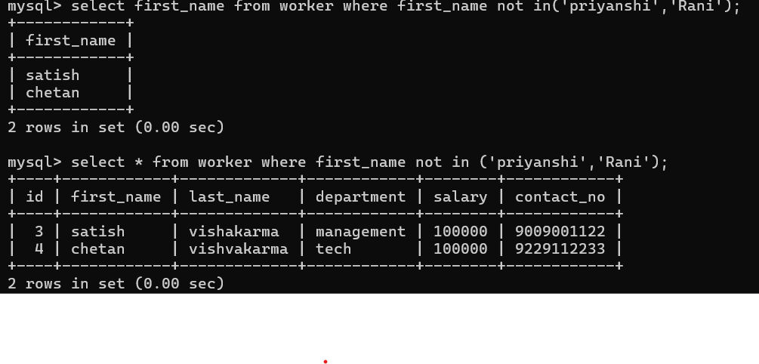Write an SQL query to print details of Workers with DEPARTMENT name as “Admin*”.

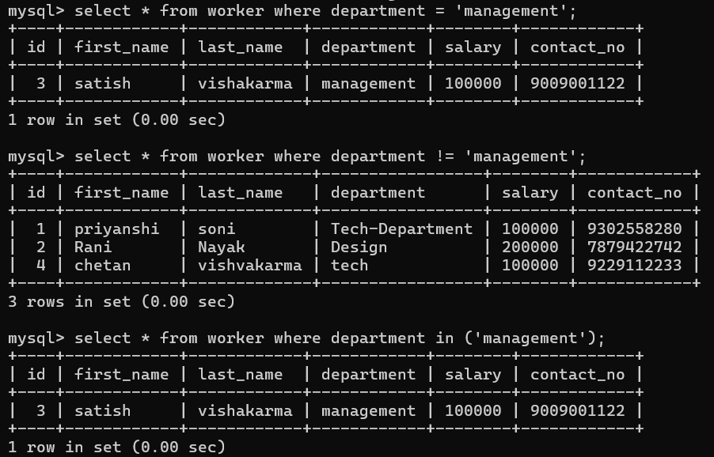Write an SQL query to print details of the Workers whose FIRST_NAME contains ‘a’.

Write an SQL query to print details of the Workers whose FIRST_NAME ends with ‘a’.

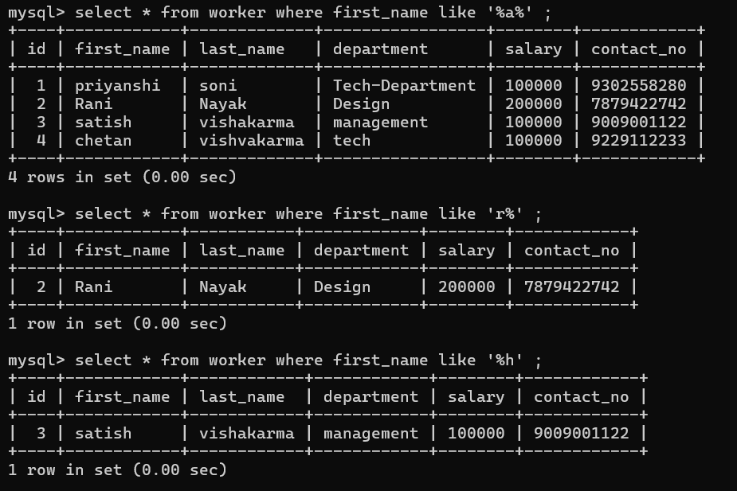 Write an SQL query to print details of the Workers whose FIRST_NAME ends with ‘h’ and contains six alphabets. 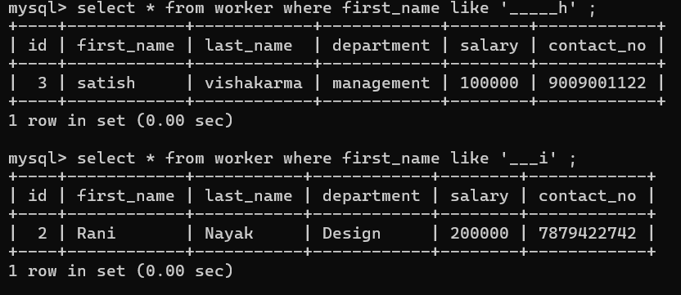

Write an SQL query to print details of the Workers whose SALARY lies between 100000 and 500000.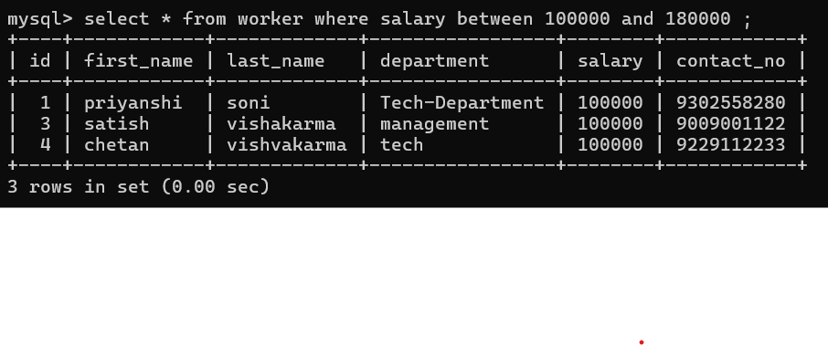Write an SQL query to print details of the Workers who have joined in Feb’2014.

**Ans** : select * from worker where year(Joining_Date)=2014 and month(Joining_Date) = 6 ;

Write an SQL query to fetch the count of employees working in the department ‘Admin’. 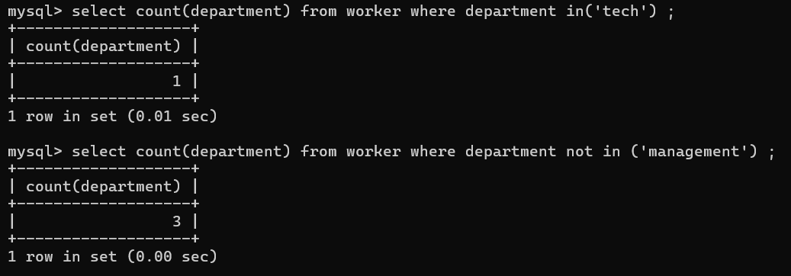

write an SQL query to fetch worker full names with salaries >= 50000 and <= 100000.

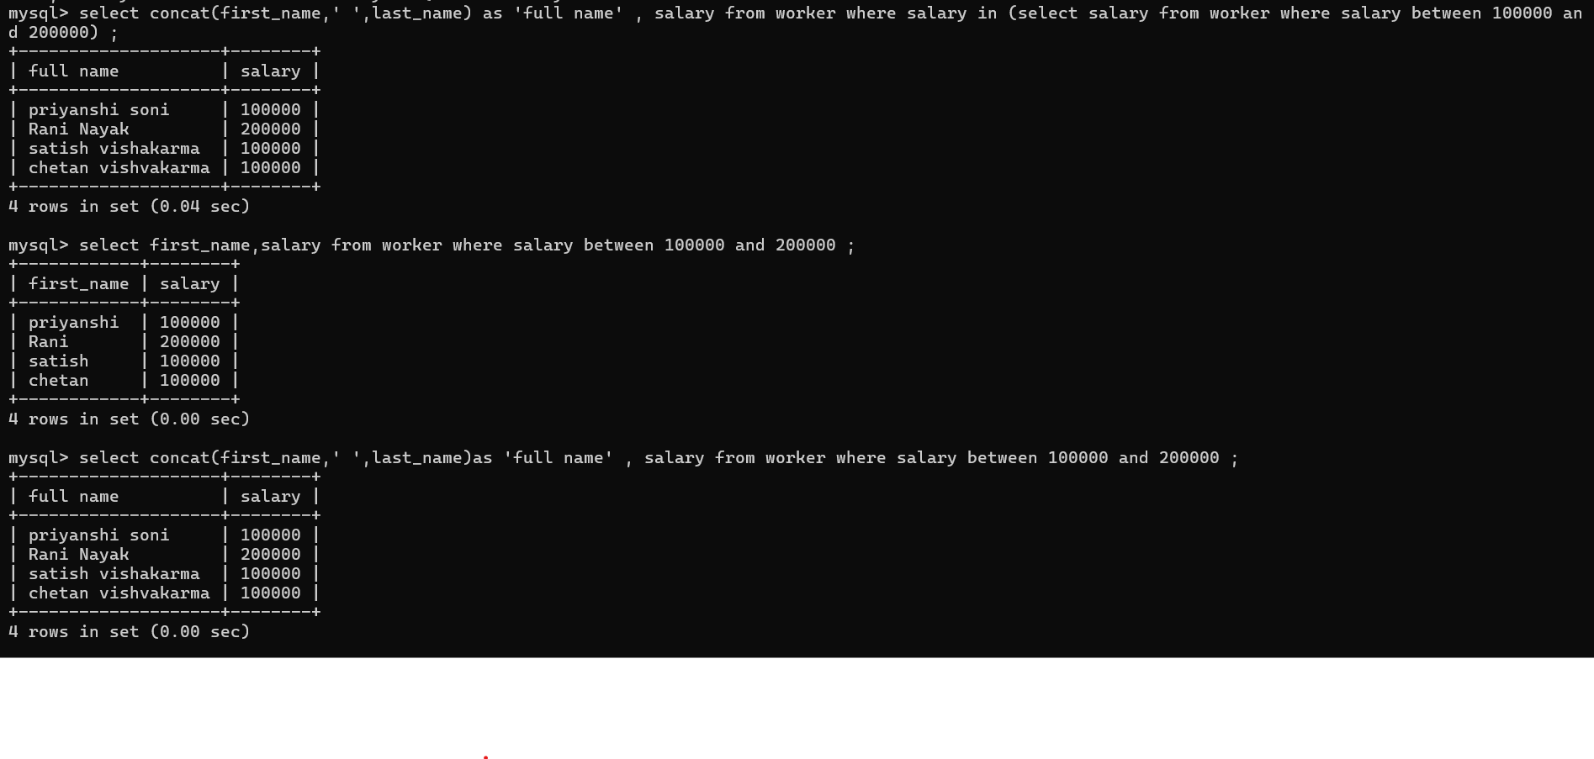Write an SQL query to fetch the no. of workers for each department in the descending order.

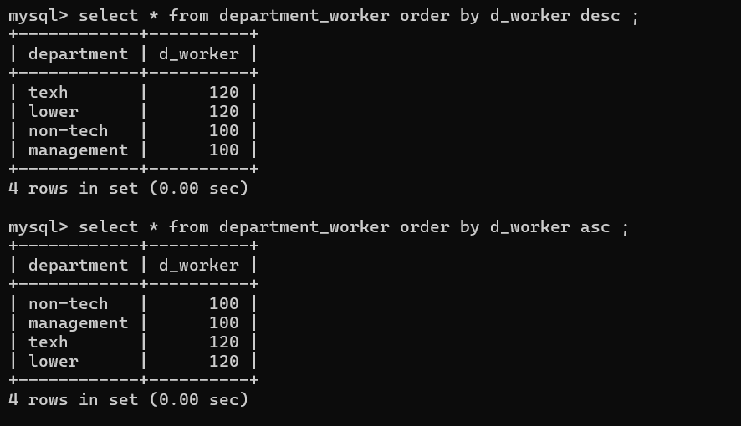

Write an SQL query to print details of the Workers who are also Managers.

Ans : select * from worker where post like ‘%manager%’ ;

Write an SQL query to fetch number (more than 1) of same titles in the ORG of different types.Ans

Write an SQL query to show only odd rows from a table.

Write an SQL query to show only even rows from a table.

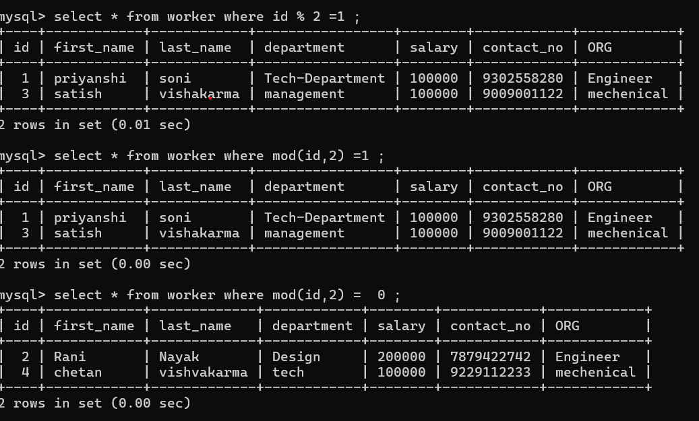Write an SQL query to clone a new table from another table. 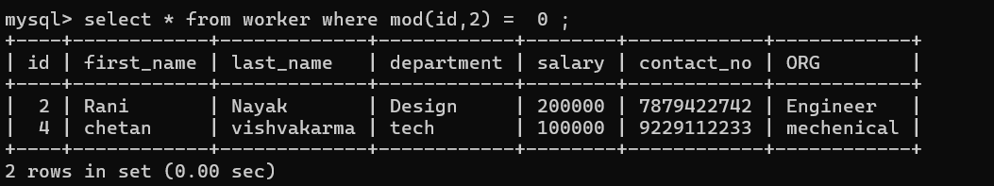

Write an SQL query to fetch intersecting records of two tables.

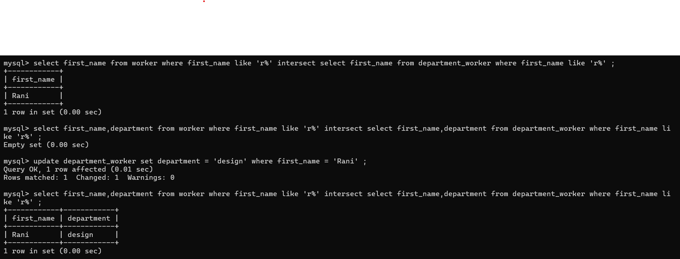Write an SQL query to show records from one table that another table does not have. 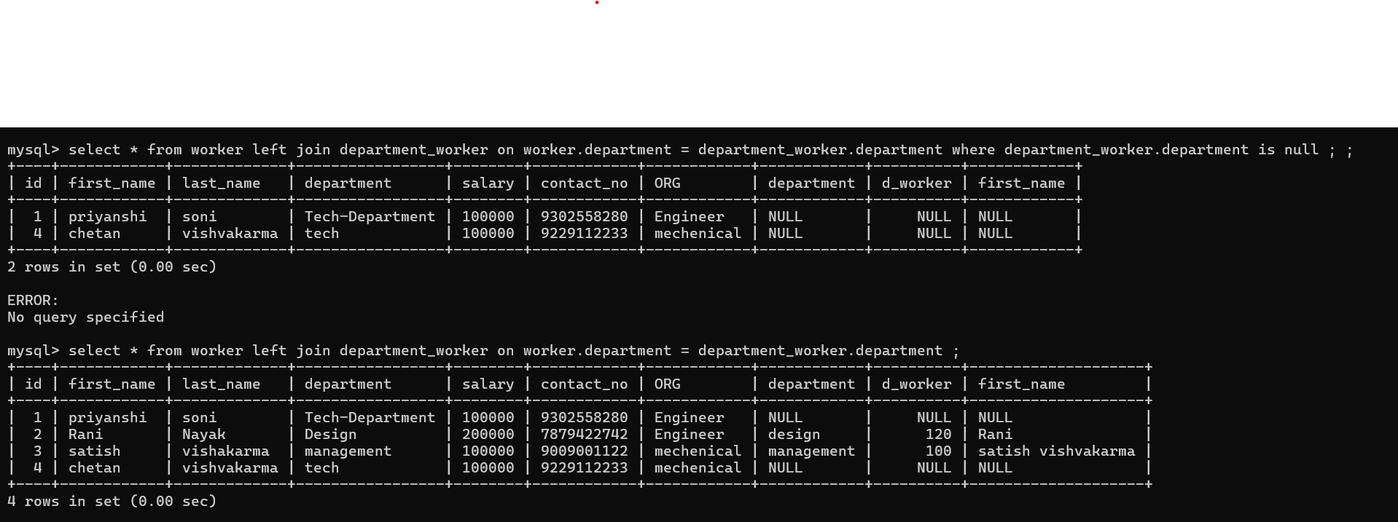

Write an SQL query to show the current date and time.ans : select CURRENT_TIMESTAMP ;

Select GETDATE() ;

Select GETTIME() ;

Write an SQL query to show the top n (say 5) records of a table order by descending salary.

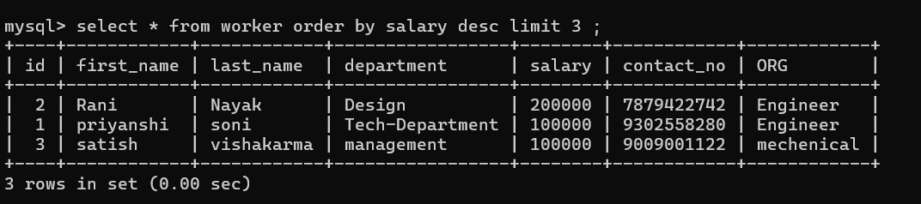Write an SQL query to determine the nth (say n=5) highest salary from a table.

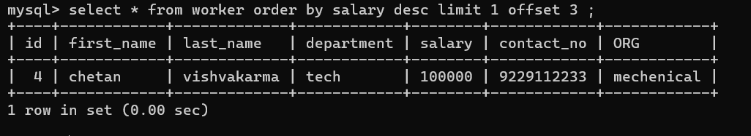Write an SQL query to determine the 5th highest salary without using LIMIT keyword.

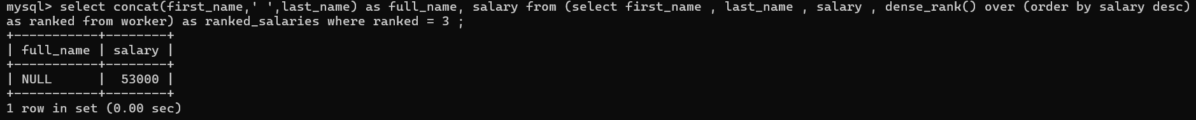select salary from worker as w1 where 5 = (select count(salary) from worker as w2 where w2.salary >= w1.salary);

Write an SQL query to fetch the list of employees with the same salary. 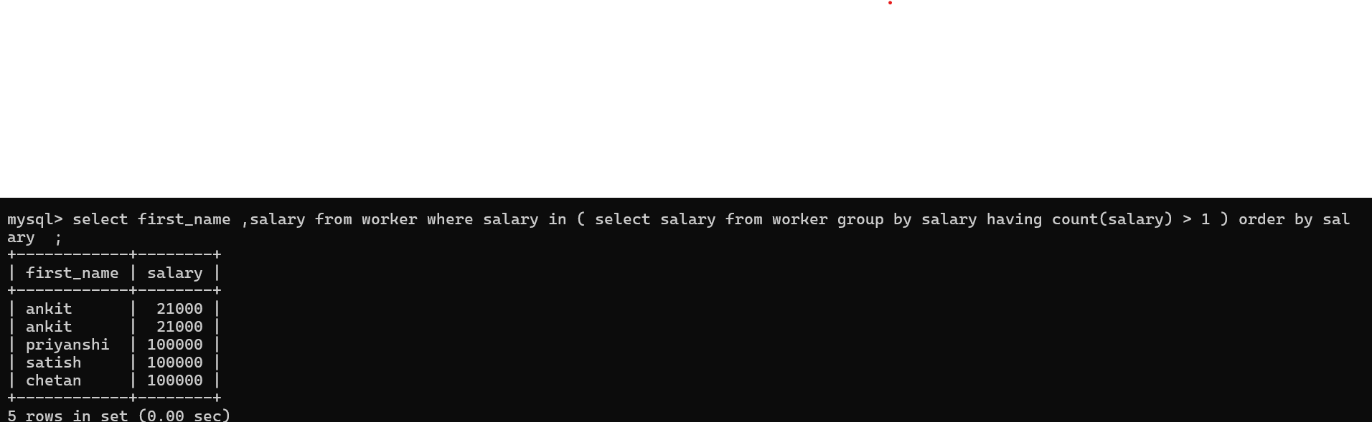

Write an SQL query to show the second highest salary from a table using sub-query. 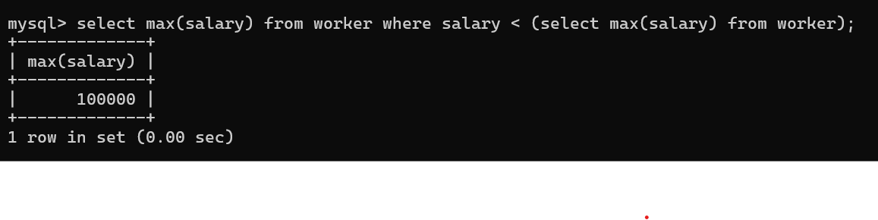

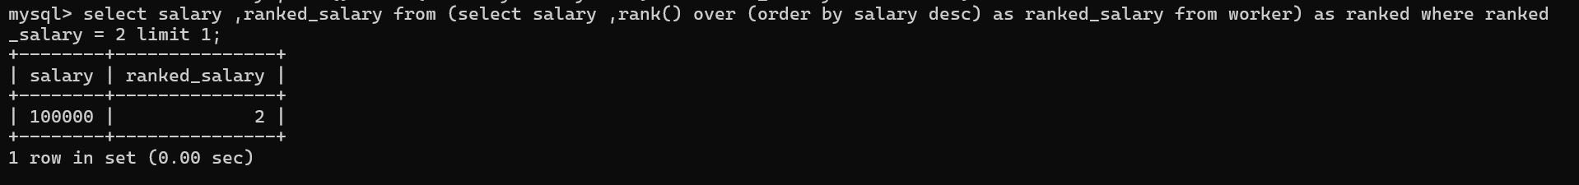

Write an SQL query to show one row twice in results from a table.

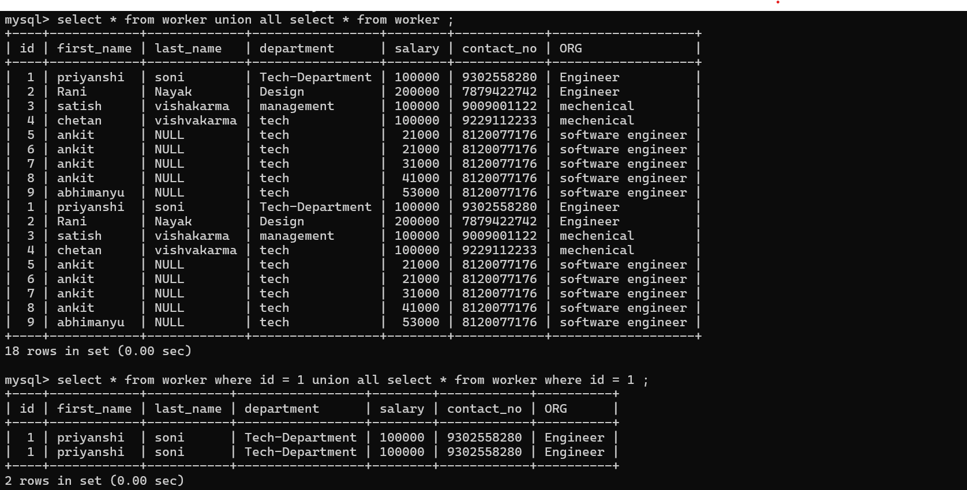

Write an SQL query to list worker_id who does not get bonus. 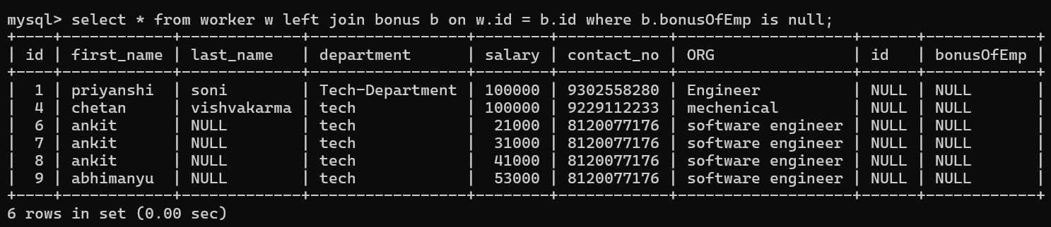

Write an SQL query to fetch the first 50% records from a table.

Write an SQL query to fetch the departments that have less than 4 people in it.

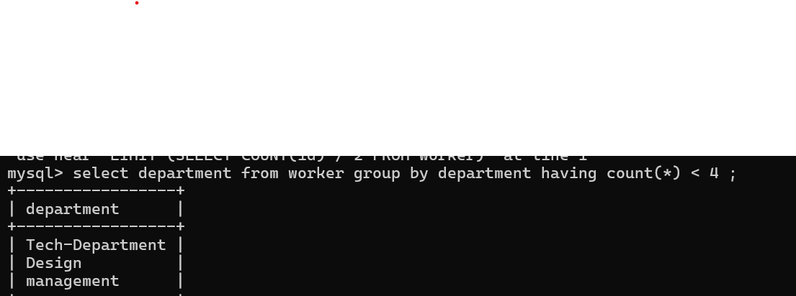Write an SQL query to show all departments along with the number of people in there. 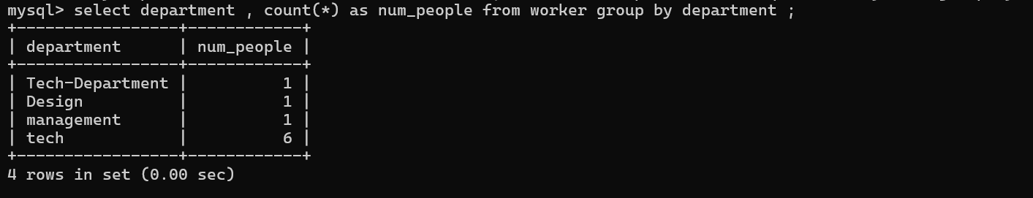

Write an SQL query to show the last record from a table.Write an SQL query to fetch the first row of a table.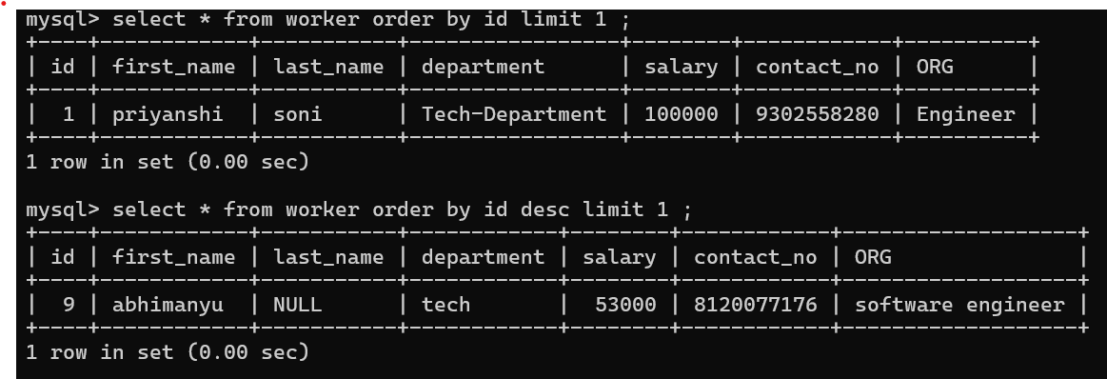

Write an SQL query to fetch the last five records from a table.

Write an SQL query to print the name of employees having the highest salary in each department .

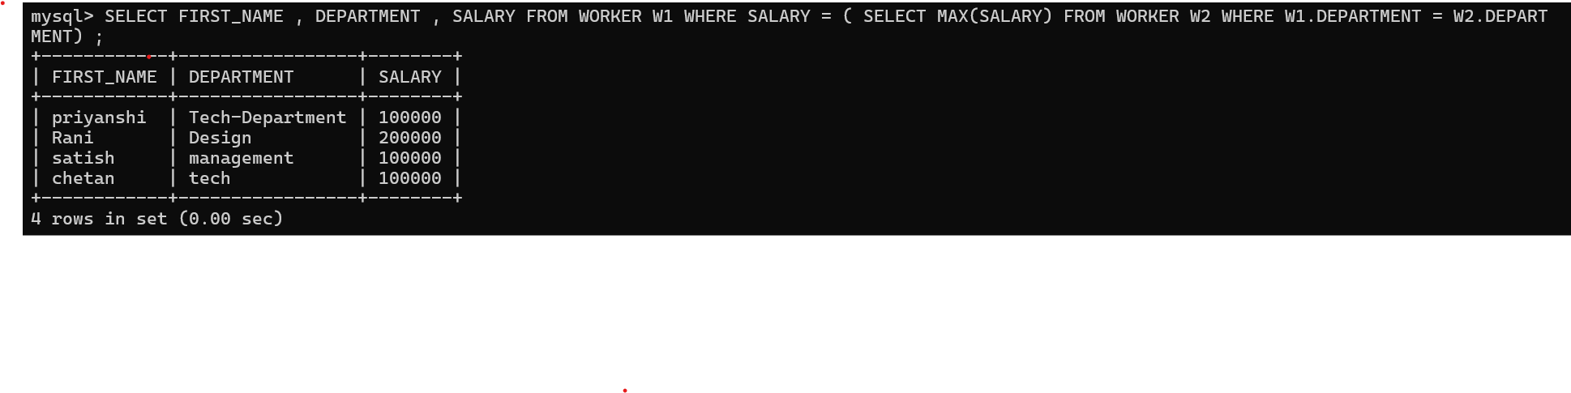­­­Write an SQL query to fetch three min salaries from a table using co-related subquery.Write an SQL query to fetch nth max salaries from a table.Write an SQL query to fetch departments along with the total salaries paid for each of them.Write an SQL query to fetch the names of workers who earn the highest salary.